Highlights

2016 - 2017

2017 National Public Opinion Survey and Congressional Briefing:
In July, PAAIA released the findings of our 2017 National Public Opinion Survey examining the attitudes of Iranian Americans toward a variety of issues affecting the community. In September, we unveiled the survey at a Congressional Briefing, co-hosted by Congressmen Gerry Connolly and Francis Rooney. The survey revealed deep concerns over increased discrimination and domestic issues – a shift from previous polling.

Public Sector Fellowship Programs:
PAAIA continues supporting the next generation of Iranian Americans through our presitigious fellowship programs. In 2017, Leela Najafii was the recipient of the Akbar Ghahary Capitol Hill Internship Program (CHIP). We also announced the launch of the Ansari Fellowship Program, a PAAIA initiative seeking to encourage and empower young Iranian-Americans to pursue careers in public service.

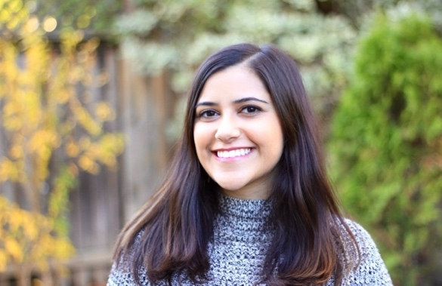

IA-100 Hosts Annual Retreat and Gala at the Montage Beverly Hills:
IA-100 proudly hosted its annual Retreat and Gala for members and special guests at the Montage Beverly Hills on October 7th. The event assembled Iranian Americans from across the country, including elected officials, foreign policy and immigration experts, best-selling authors, and members of PAAIA’s Emerging Leaders Program to discuss critically important issues to the Iranian American community and facilitate imperative conversations about how to build an influential voice and image for the Iranian American community. This year, IA-100 proudly hosted the Ranking Member of the House Intelligence Committee, Congressman Adam Schiff (D-CA), as our guest of honor.

PAAIA Launches Iranian American Profile-Raising Campaign:
PAAIA launched a digital campaign designed to proactively promote the image and build the profiles of Iranian Americans on a national scale. The campaign projects a truthful, positive image of our community as one of the most successful, well-assimilated diaspora communities in the U.S. Ultimately, this campaign will enhance our image and influence with critical policymakers on Capitol Hill.

2017 Capitol Hill Days

During the week of May 22nd, PAAIA and IA-

100 proudly hosted our Leadership Dinners and Capitol Hill Days. The dinners and meetings were a huge success, providing an opportunity to meet with over seventeen Congressional leaders from both sides of the aisle to discuss important issues to the Iranian American community.

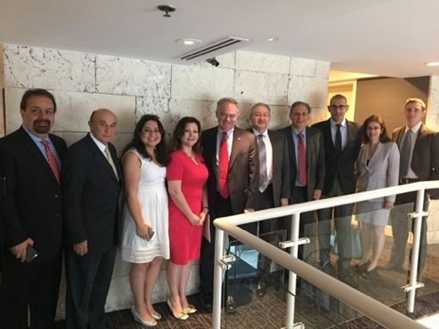

PAAIA’s Emerging Leaders Host Inaugural Retreat in Washington, DC:
During the weekend of September 8th – 10th, young Iranian American leaders convened from across the country to participate in PAAIA’s Emerging Leaders inaugural retreat. The Emerging Leaders program works with future leaders of the Iranian American community to help guide, collaborate, and facilitate discussions on ways the community can make a meaningful impact on the United States.

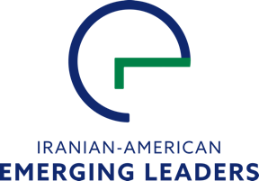

Elecitioneering Activites:
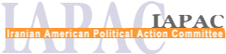
The Iranian American Political Action Committee IAPAC, the connected PAC of PAAIA, contributed over $60,000 to a bipartisan group of candidates in 2017. It also helped raise an additional $560,000 for our endorsed candidates by encouraging members to directly contribute to their campaigns. Most recently, we supported Amir Farokhi who became the first Iranian American to be elected to the Atlanta City Council and are supporting Kia Hamadanchy in his historic campaign for California’s 45th Congressional District. If successful, he will become the first American of Iranian descent to be elected to U.S. Congress. Next year, we will continue to support a bipartisan group of candidates running for public office at the federal, state, and local level.

Nowruz Celebrations:
On March 20th, 2017, we hosted our annual Nowruz reception on Capitol Hill in conjunction with Congresswoman Zoe Lofgren. Fourteen members of Congress, including House Democratic Leader Nancy Pelosi, attended the reception, as well as more than 200 Congressional staff and special guests. The event was co-hosted by twenty-three Members of Congress. We also issued a statement and action alert about PAAIA’s Nowruz resolution, introduced in the House of Representatives by Congresswoman Lofgren (D-CA). The legislation commemorates the Nowruz holiday and acknowledges the “lasting contributions” of Persian civilization to the world and the “noteworthy” impact Iranian Americans have had to the social and economic fabric of America.

Opposition to President Trump’s Discriminatory Travel Bans:

Opposing the Travel Bans in Congress:
On January 27th, the Trump Administration issued an Executive Order banning nationals from seven predominantly Muslim nations from entering the country, including Iran. The Administration has since issued two other revised travel bans in March and September. PAAIA has been on the frontlines of opposing all of the Travel Bans in Congress, calling for support of legislation opposing this discriminatory measure.

Taking the Travel Ban to Federal Court:
On March 15th, PAAIA filed a joint action lawsuit in Federal Court to permanently stop the Travel Ban. Marking the first time live testimony has been heard in any of the cases against the Travel Ban, the court heard live testimony and oral arguments from attorneys representing both sides of the case. PAAIA also filed another legal challenge in response to Travel Ban 3.0, arguing that President Trump's Executive Order unfairly targets refugees.

Standing up to Hate Crimes:
On February 28^{th,} PAAIA responded to an increase in violent incidents targeting those of Iranian descent. We drafted, organized, and released a joint public statement calling on leaders to condemn the recent escalation in hate crimes. On April 11th, we organized a fundraiser to help support Iranian American victims of hate crimes, raising almost $5,000 for survivors.
